Creating a Simple Visual Processing System over Internet Protocol with the use of Raspberry Pis
By Fabio Salgado
Overview
This system mimics the visual pipeline many audio video over internet protocol (AVoIP) systems implement. The system is composed entirely of devices networked together into a network switch which both serves as the power source and the bridge connection for all devices. This is done through the use of power over ethernet (POE), which allows the devices to both send data and power over the cat 6 ethernet cables connected.
The image maps out the pipeline: 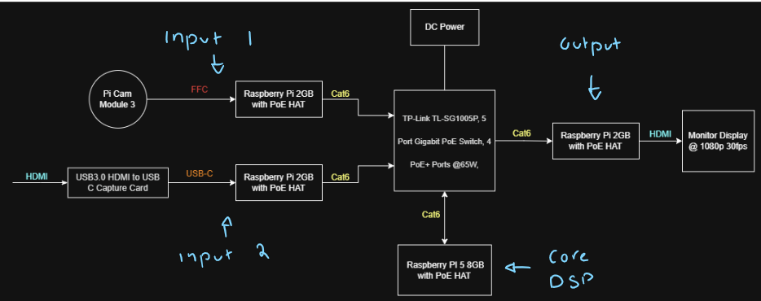
As seen, the Raspberry Pis serve 1 of 3 purposes. Pis can serve as encoders, taking in input data, such as the camera feed (input 1) or device whose screen you wish to mirror (input 2), and compressing the data so it can be sent across the cat 6 cable to the switch. This compression is vital as the switch has a restriction of 1 Gbps when handling data. Secondly a Pi can serve as a decoder, these Pis take encoded data on the cat6 line and “unwrap” it so that the data can be fully utilized. In this project the Pi labeled output is decoding the data to display the image on a monitor.
Finally, a Pi can serve as the core. The core is responsible for routing inputs to outputs, applying any digital signal processing (DSP), and finally hosting a web UI the user can interact with. This Pi must both decode the incoming data to apply DSP and then encode the data to be sent to another source. This is why the newer Raspberry Pi 5 is being used, this Pi takes on most of the processing load. The core will be the focus of the rest of the report, as it contains the prevalent DSP topics. Consequently, much of the work completed will not be fully touched upon, but for brevity sake is necessary. The C++ files, python web UI files, and startup display service for the output display are all included as attachments. Note that this system is configured to work on power up. This may require users to configure Pis to behave as such. Furthermore, to use the web UI effectively users must create their own virtual environment within the AV_CORE folder. (the local environment created in my project cannot be copied over due to USB file system compatibility)

Visual filters: 2D convolution
Navigating the attachments to the AV_CORE folder, in the sub folder labelled av_dsp there is a cpp file called filter.cpp. Here is where the majority of the visual processing occurs. This program implements 4 filters and brightness and contrast settings. Focusing on the filters first, note that with images the usual approach of convolution is not entirely sufficient. Since we are dealing with pixel changes in both the horizontal and vertical directions it becomes necessary to perform 2 dimensional convolution. The approach taken is using 3x3 kernels. These kernels represent the changes applied to pixels surrounding the evaluated pixel. Take for instance the sharpen kernel listed:

0 | -1 | 0
-1 | 5 | -1
0 | -1 | 0

Recall that the center pixel is the evaluated pixel. In this case the middle pixel's new value is calculated by performing multiplication of the weights listed to each pixel and then summing the values to yield a new center value. This calculation is performed individually across 3 channels to yield the new red, green , and blue values of the pixel. As a demonstration, consider the case of a bright pixel surrounded by grey pixels (ignore color for the sake of simplicity). The pixel cluster is as follows:
50 | 50 | 50
50 | 200 | 50
50 | 50 | 50

See that the higher value bright pixel 200 is brighter than the more grey pixels of value 50 surrounding it. Performing the sharpen kernel math yields: (50*0) + (50*-1) + (50*0) + (50*-1) + (200*5) + (50*-1) + (50*0) + (50*-1) + (50*0) = 1000 - 200 = 800. So in theory the new value of the center pixel is 800. Note however that pixel values are listed from values 0 to 255, so the 800 is clamped to cap at 255. The resulting pixel array is now:
50 | 50 | 50
50 | 255 | 50
50 | 50 | 50

Notice that the center pixel is now brighter, giving the effect of “sharpening”.
It should be clear now that by varying kernel values, different filter effects can be applied to pixels. The other kernel based filters applied are: blurring, embossing, and edge detection. The blurring kernel has the opposite effect of the sharpening filter:
1 | 2 | 1
2 | 4 | 2
1 | 2 | 1

See how the surrounding pixels values are weighted greater, closing the gap in intensity to the center pixel. The blur kernel also has a divisor value applied to the end result. This divisor value helps pronounce the effect of the blurring. In this case the divisor is 16. For the embossing filter:
-2 | -1 | 0
-1 | 1 | 1
0 | 1 | 2

Notice how we are skewing pixel values on the bottom right brighter and the top left darker. This gives the illusion of an image that has been raised. Finally in edge detection:

-1 | -1 | -1
-1 | 8 | -1
-1 | -1 | -1

Note how the kernel extremely highlights differences in values between the center pixel and its surrounding pixels.
Included in the attachments are videos where the effects of these filters can be seen applied to both camera images and screen shared images.

Visual filters: threading
The system is processing video in full HD at 30 fps. This means there are 1920 x 1080 = 2,073,600 pixels. Furthermore, recall that each pixel has a red, green and blue value. This means 3 channels are present. So we effectively have 2,073,600 x 3 = 6.22 million pixel evaluations to process. This number only grows larger when taking into account all the multiplications that take place within each pixel evaluation! In other words, this convolution method is very computationally expensive. There were major performance issues because of this DSP related approach. The solution as seen in the filter code, is to make use of the 4 cores on the Raspberry Pi 5. By segmenting the image into 4 horizontal regions of grouped pixels, the use of threads can be implemented so that processing runs concurrently. This significantly improves processing performance and allows the system to maintain approximately 30 fps under the selected operating conditions.

Visual filters: Contrast and brightness
Unlike the previous processing, both contrast and brightness control does not require pixel comparison. Instead each pixel is uniformly affected. Specifically our output pixel takes on the value: output = contrast * (input -128) + 128 + brightness. The implementation of contrast makes use of a midpoint concept. The midpoint between 0 and 255 is around 128. Without the subtraction and addition of the 128, true contrast is not attained. For instance, take a value of 50, a relatively grey pixel (once again ignore color for simplicity sake in this demonstration) . If contrast is applied by say a factor of 1.1, the pixel should get darker. Larger contrast factors make saturated pixels more saturated, and dulled pixels more dull. Assuming no brightness change, the new value for the pixel becomes 1.1*(50-128)+128 = 42.2. The pixel indeed becomes darker. Take a lighter pixel, say of value 180. The output is then 1.1*(180-128)+128 = 185.2. The pixel indeed becomes lighter. This process is applied across all 3 color channels to yield the contrasted pixel. Note brightness is simply applied uniformly to all pixels after each channel's contrast calculation. Finally, outputs are clamped to ranges of 0 to 255, as that is a pixel’s value range.

Filter implementation:
In the main AV_CORE subfolder labeled av_dsp there is a program titled main.cpp. This is the main point of execution for the entire system. Most of the function of the program will not be explained here. Rather a focus on the DSP aspect is taken as mentioned before. On line 260 there is a comment titled // BLUR AND SHARPEN CAN BE APPLIED SEVERAL TIMES TO INCREASE THEIR EFFECT. Take note of the looped application of blur and sharpen. Because of the 3x3 kernel approach taken, blurring and sharpening only look at immediate neighboring pixel values to determine the effect. Consequently sharpening and blurring can seem minor. The remedy for this is to have these filters apply multiple times to pronounce the effect. By increasing the amount of times the filter is applied, these filters' effects become more obvious. The videos attached demonstrate this.

Closing remarks / reflection
There was much excitement in trying to complete this system as a whole, and for the most part it is successfully a prototype demonstrating the fundamental architecture of an AvoIP system. That being said, the scope was very large. Looking back, advice should have been taken to focus more acutely on one aspect. A change to the DSP side that comes to mind is kernel size. A small 3x3 kernel was chosen as it lowers the amount of operations per pixel, however it would be interesting to see the effects of larger kernels on performance and filter quality. All thoughts aside, the project was a great look into the AV world and image processing.
Sources:
Kernal ideas:
https://docs.opencv.org/4.5.4/d4/d13/tutorial_py_filtering.html
brightness and contrast ideas:
https://docs.opencv.org/4.13.0/d3/dc1/tutorial_basic_linear_transform.html

